|  |  |
| --- | --- |
|  | **FPT ACADEMY INTERNATIONAL**  **FPT – APTECH COMPUTER EDUCATION** |

**Centre Name: ACE-THUDUC-1-FPT**

**Address: 391A Nam Ki Khoi Nghia District 3, Ho Chi Minh City, Viet Nam.**

Garden World

|  |  |  |
| --- | --- | --- |
| **Supervisor.** | Mr. Nguyen Phat Tai | |
| **Batch.** | T3.2307.E1 | |
| **Group.** | Group 3 | |
| **Serial No.** | **Enrollment Number** | **Student Name** |
| 1. | Student1491500 | Nguyen Minh Hieu |
| 2. | Student1491486 | Nguyen Lam Son |
| 3. | Student1496446 | Phan Sy Nguyen |
| 4. | Student1492041 | Bui Duong Hoai Trung |

NOV-14-2023

**This is to certify that**

**Mr/Ms:**

Nguyen Minh Hieu

Nguyen Lam Son

Phan Sy Nguyen

Bui Duong Hoai Trung

**has successfully designed & developed**

eProject: Garden world

**Submitted by: Nguyen Minh Hieu**

**Date of issue: 14-Nov-2023**

**Authorized Signature: Hieu**

**TABLE OF CONTENTS**

ACKNOWLEDGEMENT 3

SYNOPSIS 3

PROBLEM DEFINITION 3

CUSTOMER'S REQUIREMENTS SPECIFICATIONS (CRS) 3

Client: Venus Handicrafts 3

Business/Project Objective: 3

Hardware/ Software Requirements: 4

SCOPE OF THE WORK (IN BRIEF) 5

Architecture and design of the system 6

Diagram of the website 7

TASK SHEET REVIEW 1 8

SITE MAP 9

MOCK OF THE WEBSITE 10

1. HOMEPAGE 10

2. GARDENING TIPS 11

3. PRODUCT 12

TASK SHEET REVIEW 2 17

WEBSITE DESCRIPTION 15

1. HOMEPAGE 15

2. GARDENING TIPS 16

3. PRODUCT 17

4. DETAIL 18

SOURCE CODE 23

1. HOMEPAGE 23

2. GARDENING TIPS 25

3. PRODUCT 27

4. DETAIL 29

TASK SHEET REVIEW 3 33

# ACKNOWLEDGEMENT

On behalf of all members of Team 3, I would like to thank all of you for your hard work and support to successfully complete this eProject. Especially Mr. Nguyen Phat Tai, our teacher, has helped us a lot since the day we started studying at FPT Aptech. With this eProject, the Teacher guided us very enthusiastically and heavily. Thanks to his guidance, we were able to complete this project. Additionally, I would like to thank all team 3 members, each team member worked continuously for 4 weeks to complete this project. Last but not least, we would like to thank our family for always supporting and creating the best conditions for us to focus on the project and believe in the dreams we pursue.

# SYNOPSIS

GARDEN WORLD is selling various types of Furniture’s. The company advertises by distributing the pamphlets, advertising on television and so on. Due to rapid development in internet field, the company decides to launch a website where people will get all the information about the various products available with them easily. You are supposed to create a website for them with the below mentioned requirement specifications.

# PROBLEM DEFINITION

The Web site is to be created based on the following requirements.

1. Home page with suitable logo and related banners/information.
2. There should be menu with submenu (as per requirement)
3. Users should be able to find information regarding various gardening techniques/tips for better gardening
4. There should be list of different tools needed for gardening along with the information as how to use, sample videos.
5. Along with the tools site should also include the information on
   1. Soil & fertilizers
   2. Pesticides for plants
   3. Seeds details
6. There should be a section for selecting proper pots/pot plates, wall mounted/wall hanging brackets , pot hangers, railing brackets etc
7. A section including following accessories should also be there
   1. Miniature garden toys
   2. Gardening accessories
   3. Decorative pebbles
8. There should be a special section where suggestions for buying various related products can be provided.
9. Informative and illustrative videos are welcomed in the website (keep the size limited)
10. There should also be a section where user can check for some related books

# CUSTOMER'S REQUIREMENTS SPECIFICATIONS (CRS)

### Client: Garden world

### Business/Project Objective: Garden world

The Objective of this program is to give a sample project to work on real life projects. These applications help you build a larger more robust application.

The objective is not to teach you HTML/JavaScript/Dreamweaver/HTML5 but to provide you with a real life scenario and help you create basic applications using the tools.

You can revise the chapters before you start with the project.

This project is meant for students who have completed the module of ***Dreamweaver***. These programs should be done in the Lab sessions with assistance of the faculty if required.

It is very essential that a student has a clear understanding of the subject. Students should go through the project and solve the assignments as per requirements given.

Kindly get back to eProjects Team in case of any doubts regarding the application or its objectives.

**Input to the system:**

* + - * Browsing products based on brands, type of appliances..

**Output from the system:**

* A menu that will categorize all the functions of the site.
* Display the list of available albums category wisely.
* Perform the brief comparison by showing 2 products of the same type with their details.
* Site should be able to provide brief introduction/history about the company under About Us page.
* The location of the company is in Contact Us page.
* Besides the above requirements, the site should have look and feel as per the industry standards.

**Expected delivery date:** 14-Nov-2023.

**List of deliverables:**

* + - * Document Word.
      * User Guide.
      * Source code.

### Hardware/ Software Requirements:

**Hardware**

* + A minimum computer system that will help you access all the tools in the courses is a Pentium 166 or better.
  + 64 Megabytes of RAM or better.

**Software**

* + Notepad/HTML editor.
  + Dreamweaver, VisualStudioCode.
  + IE 5.0/ Netscape 6.0.

# 

# SCOPE OF THE WORK (IN BRIEF)

**The team has discussed and has agreed about the website layout as shown briefly below:**

1. **Homepage**: Showing brief introduction about the company and type of products that it is selling.
2. **Products**: Containing its products with their details and images categorized by type.
   1. All Products
   2. Soil Fertilizers
   3. Pesticides For Plants
   4. Seeds
   5. Plants Pots
      1. Pots
      2. Pots Plates
      3. Wall Mounted
      4. Wall Hanging Brackets
      5. Pot Hanggers
      6. Railing Brackets
   6. Accessories
      1. Minture Garden Toys
      2. Decorative Pebbles
      3. Gardening Accessories
3. **Gardening Tips**: Illustrative images and videos help users interested in the product better understand the product

# 

# Architecture and design of the system

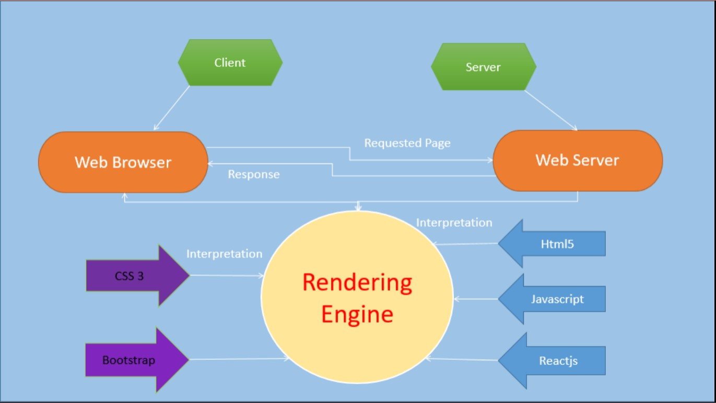

# Diagram of the website

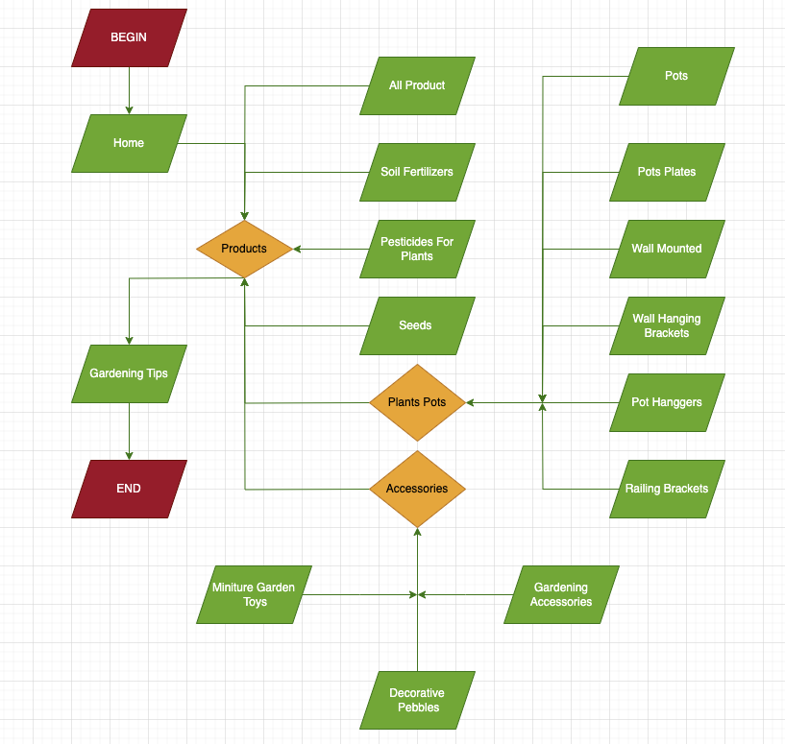



**TASK SHEET REVIEW 1**

|  |  |  |  |  |  |  |  |
| --- | --- | --- | --- | --- | --- | --- | --- |
| **Project Ref. No.:**  **eP/Advertisement Portal Management**  **System/01** | | **Project Title:** | **Activity Plan Prepared By:** | **Date of Preparation of Activity Plan:** | | | |
| **Sr.**  **No.** | **Task** | **Actual**  **Start Date** | **Actual Days** | **Team**  **Mate Names** | **Status** |
| 1 | Problem Statement | GARDEN WORLD | Son | 14-Oct-2023 | 1 | Nguyen, Hieu,  Son | Completed |
| 2 | Analysis of the requirements about the website | 14-Oct-2023 | 1 | Nguyen, Hieu,  Son | Completed |
| 3 | The scope of the work (in brief) | 14-Oct-2023 | 1 | Nguyen, Hieu,  Son | Completed |
| 4 | Architecture and design of the system | 14-Oct-2023 | 1 | Nguyen, Hieu,  Son | Completed |
| 5 | Diagram of the website | 14-Oct-2023 | 1 | Nguyen, Hieu,  Son | Completed |
| 6 | Task Sheet | 14-Oct-2023 | 1 | Nguyen, Hieu,  Son | Completed |

|  |  |
| --- | --- |
| **Date: 21/10/2023** | |
| Signature of Instructor:  **Mr. Nguyen Phat Tai** | Signature of Team Leader:    **Ms. Nguyen Minh Hieu** |

# SITE MAP



# MOCK OF THE WEBSITE

1. **HOMEPAGE**

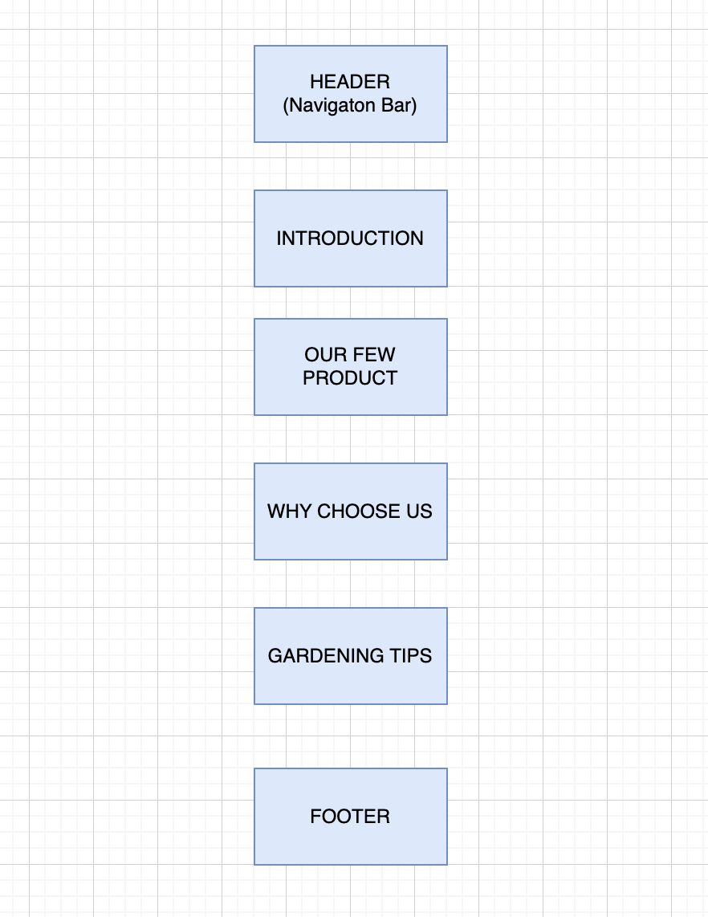

## PRODUCT

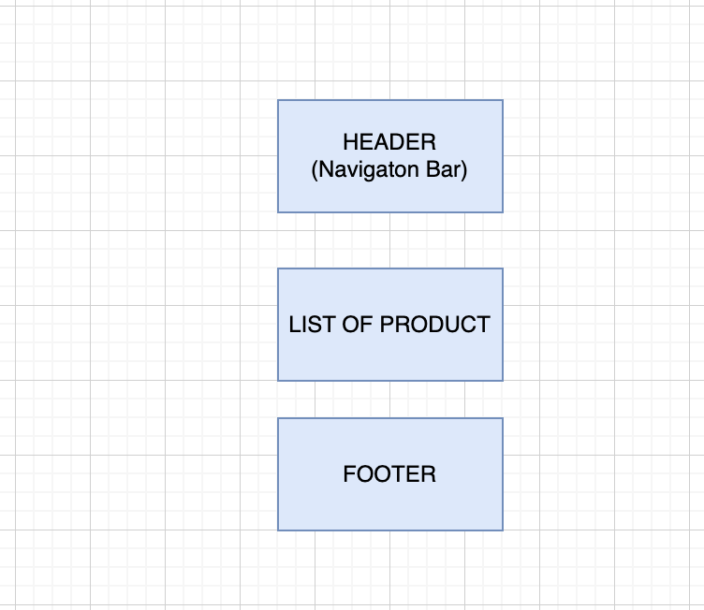

1. **GARDENING TIPS**

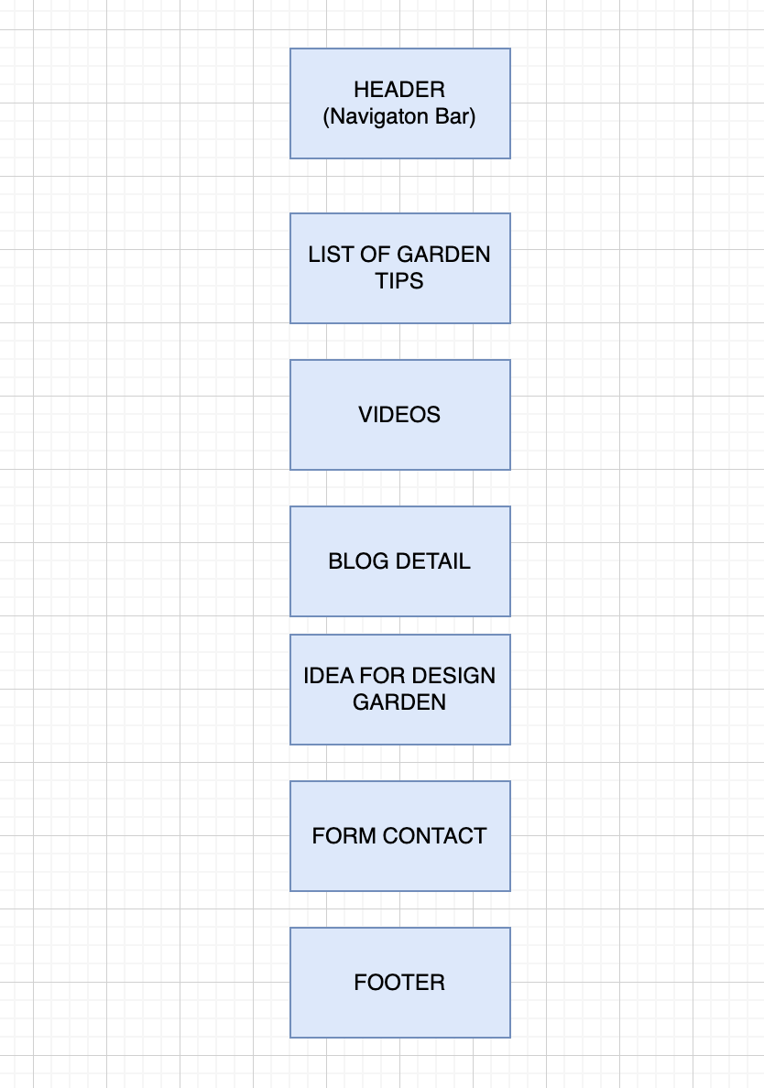

# TASK SHEET REVIEW 2

|  |  |  |  |  |  |  |  |
| --- | --- | --- | --- | --- | --- | --- | --- |
| **Project Ref. No.:**  **eP/Advertisement**  **Portal Management System/01** | | **Project Title:** | **Activity Plan Prepared By:** | **Date of Preparation of Activity Plan:** | | | |
| **Sr.**  **No.** | **Task** | **Actual**  **Start Date** | **Actual Days** | **Team**  **Mate Names** | **Status** |
| 1 | Site map | GARDEN WORLD | Son | 26-Oct-2023 | 1 | Nguyen, Hieu,  Son | Completed |
| 2 | Mock of the website | 26-Oct-2023 | 1 | Nguyen, Hieu,  Son | Completed |
| 3 | Task Sheet | 26-Oct-2023 | 1 | Nguyen, Hieu,  Son | Completed |

|  |  |
| --- | --- |
| **Date: 26/10/2023** | |
| Signature of Instructor:  **Mr. Nguyen Phat Tai** | Signature of Team Leader:  **Ms. Nguyen Minh Hieu** |

# WEBSITE DESCRIPTION

## HOMEPAGE

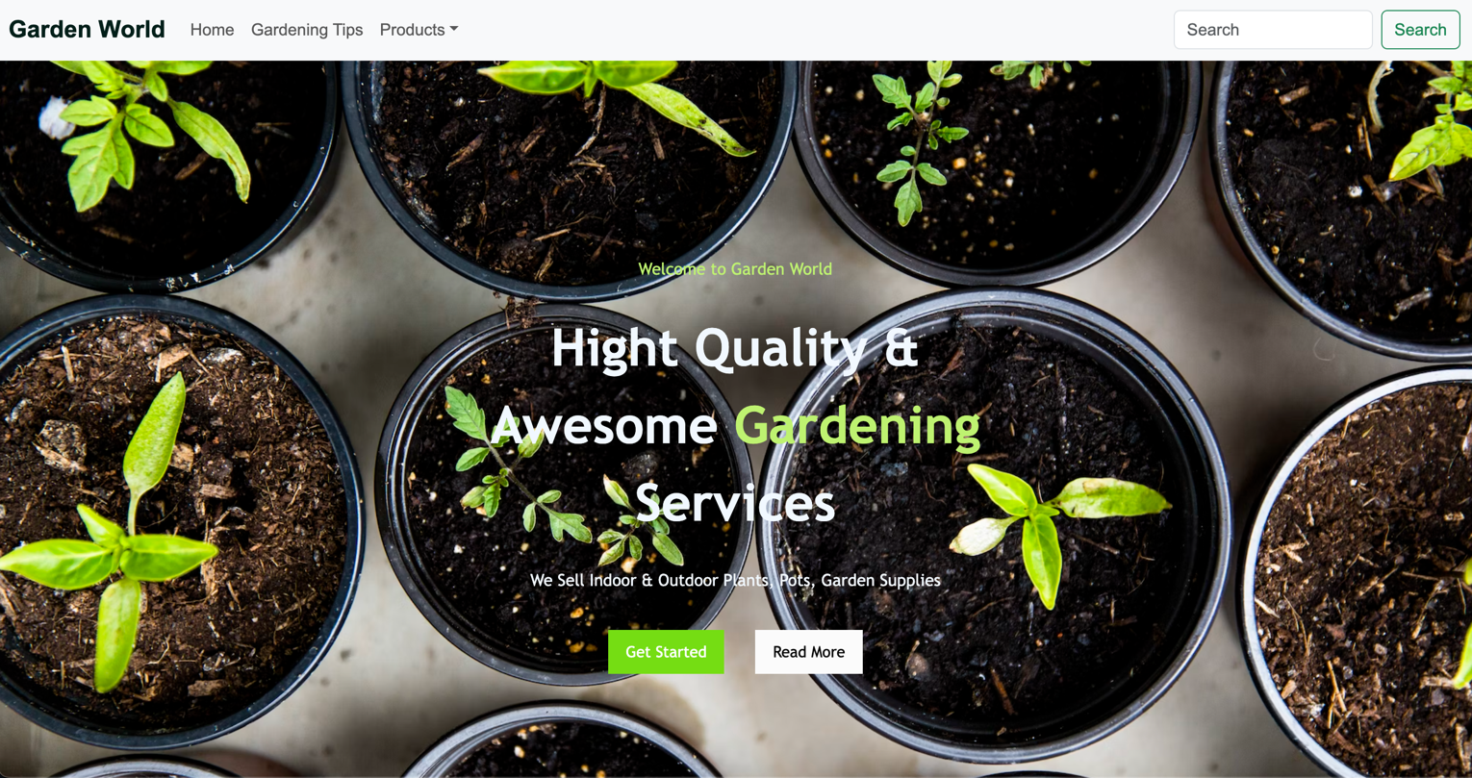

**Figure 1:** Header

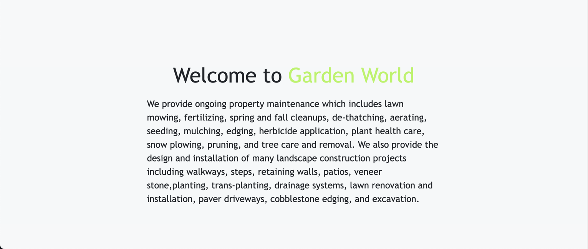

**Figure 2:** Welcome

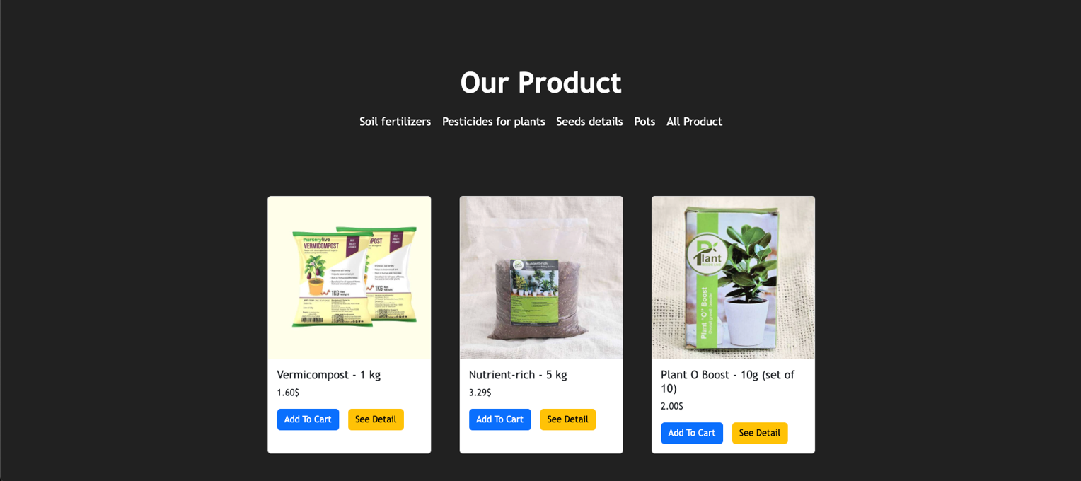

**Figure 3:** Our Product

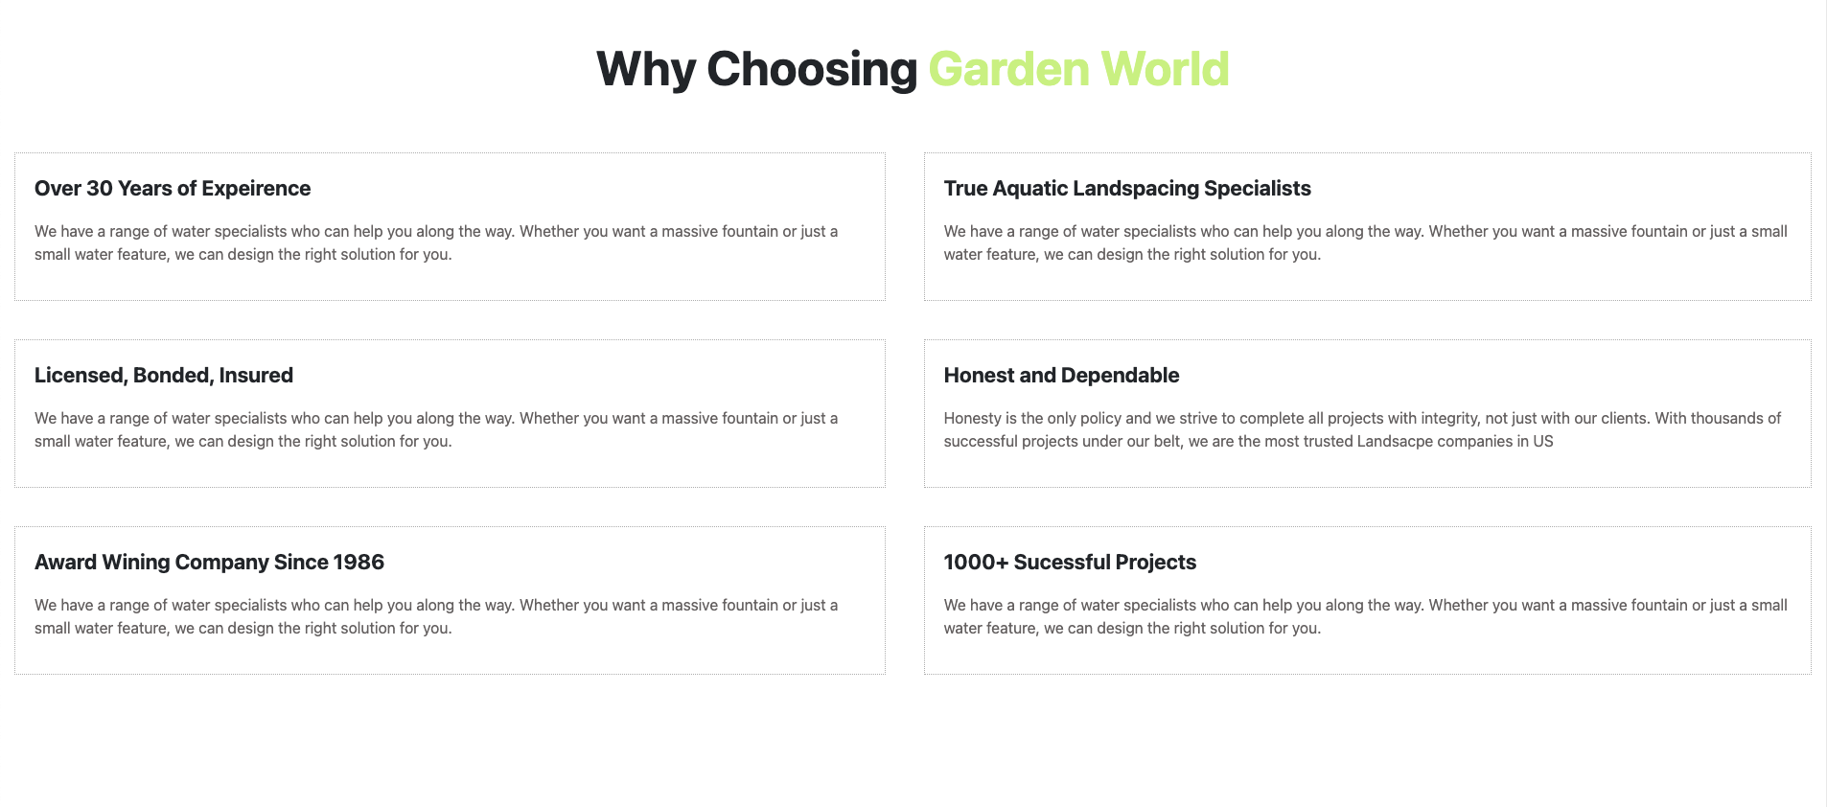

**Figure 4:** Why Choose Us

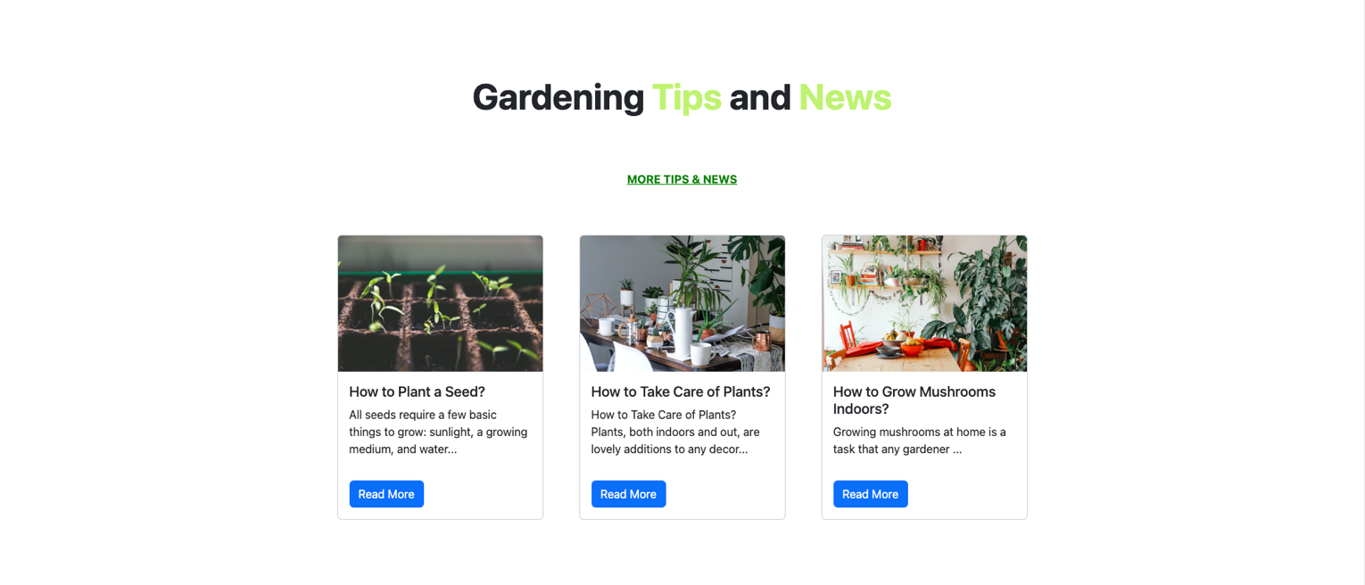

**Figure 4:** Gardening Tips

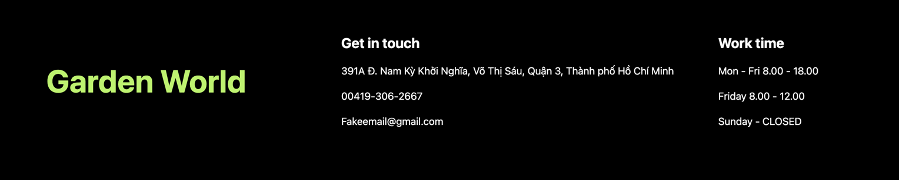

**Figure 5:** Footer

## GARDENING TIPS

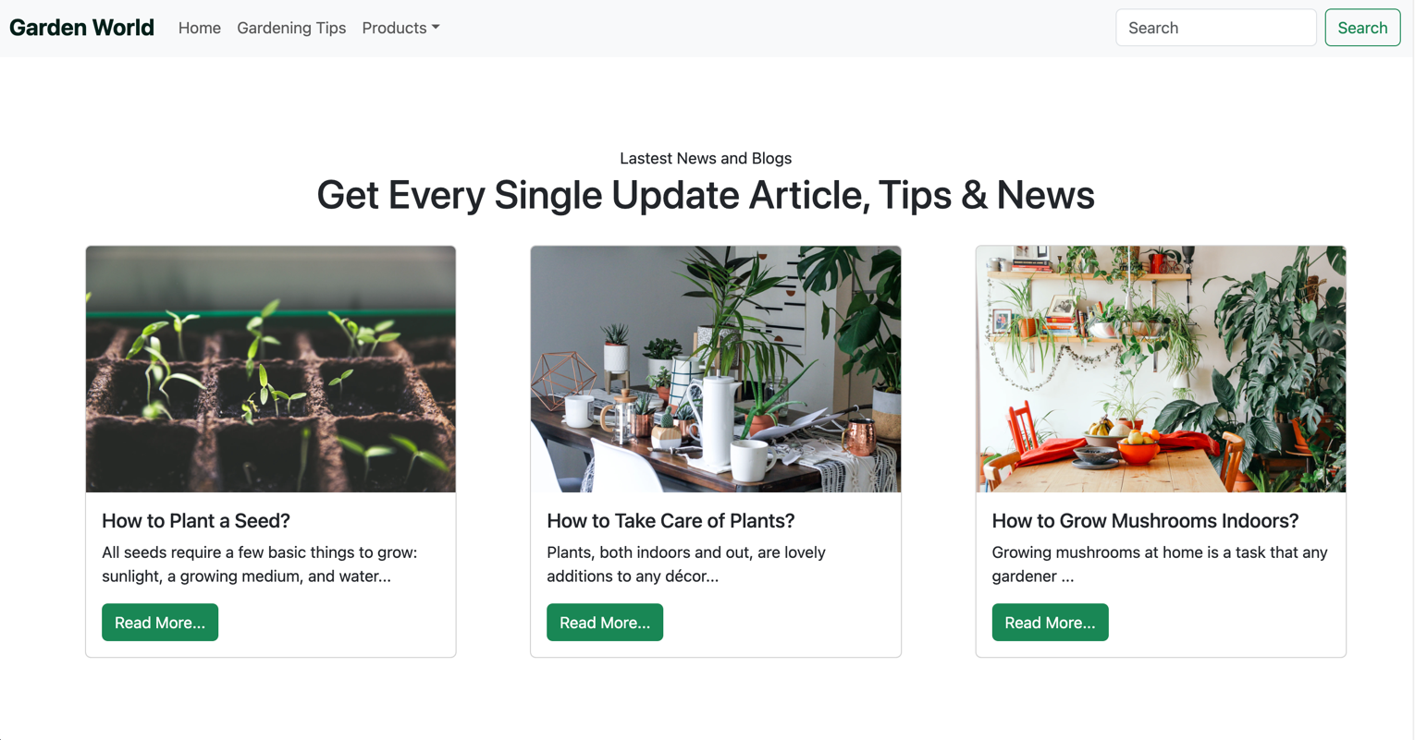

**Figure 1:** Header

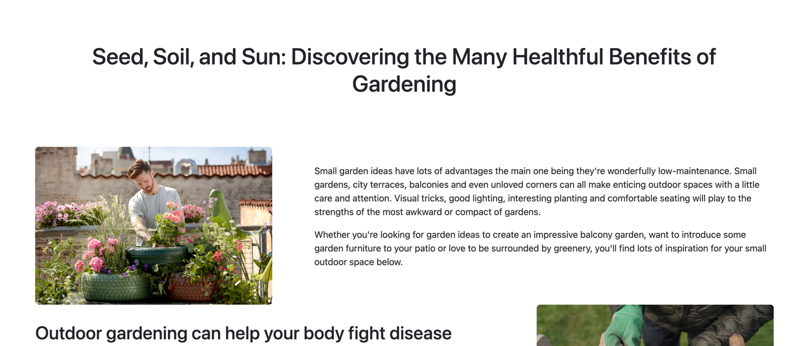

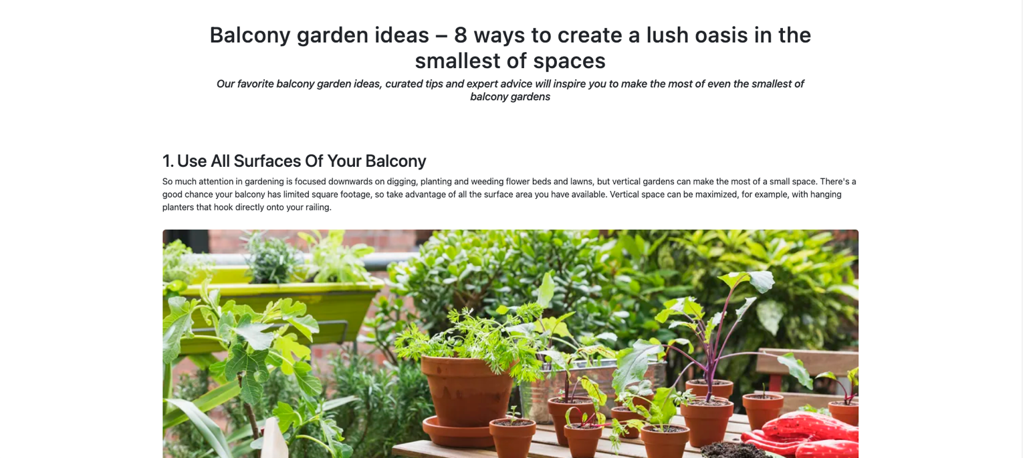

**Figure 2:** Gardening Tips

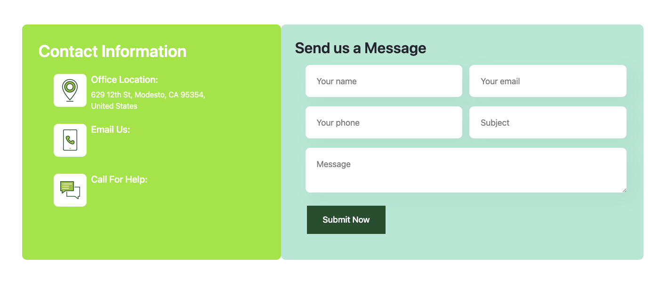

**Figure 3:** Form Contact



**Figure 4:** Footer

## PRODUCT

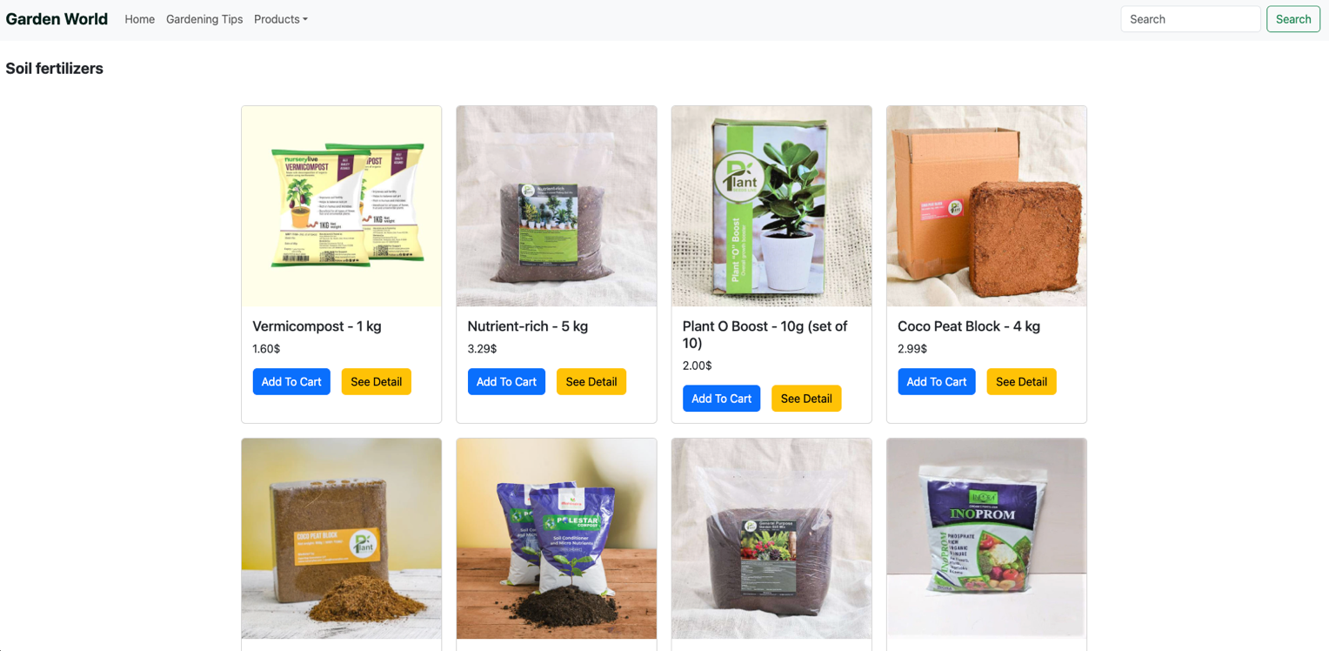

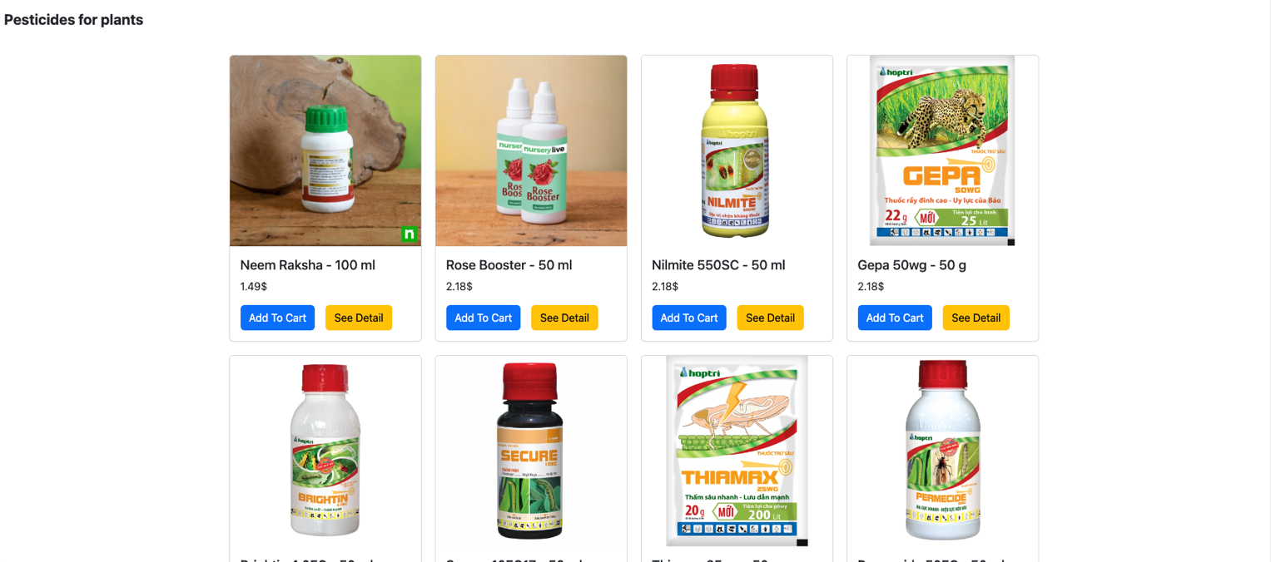

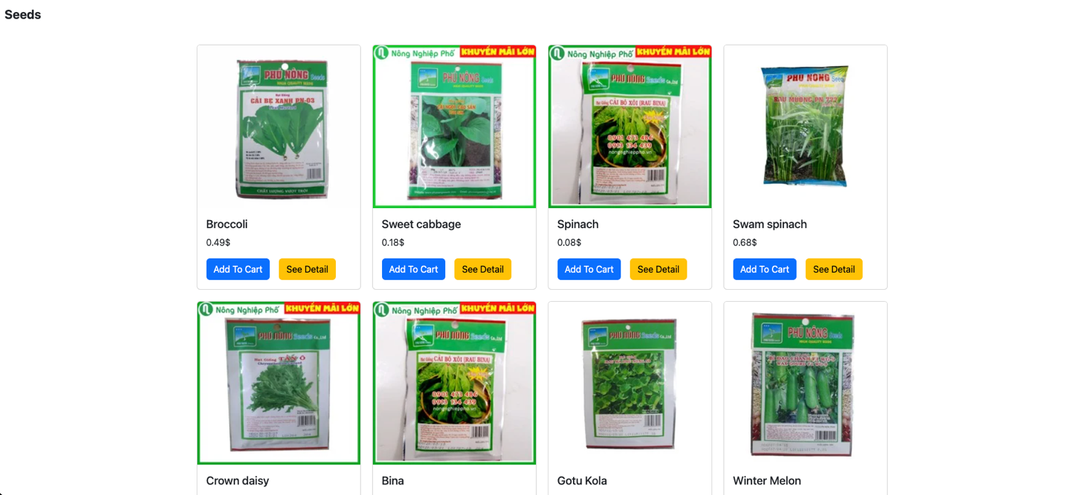

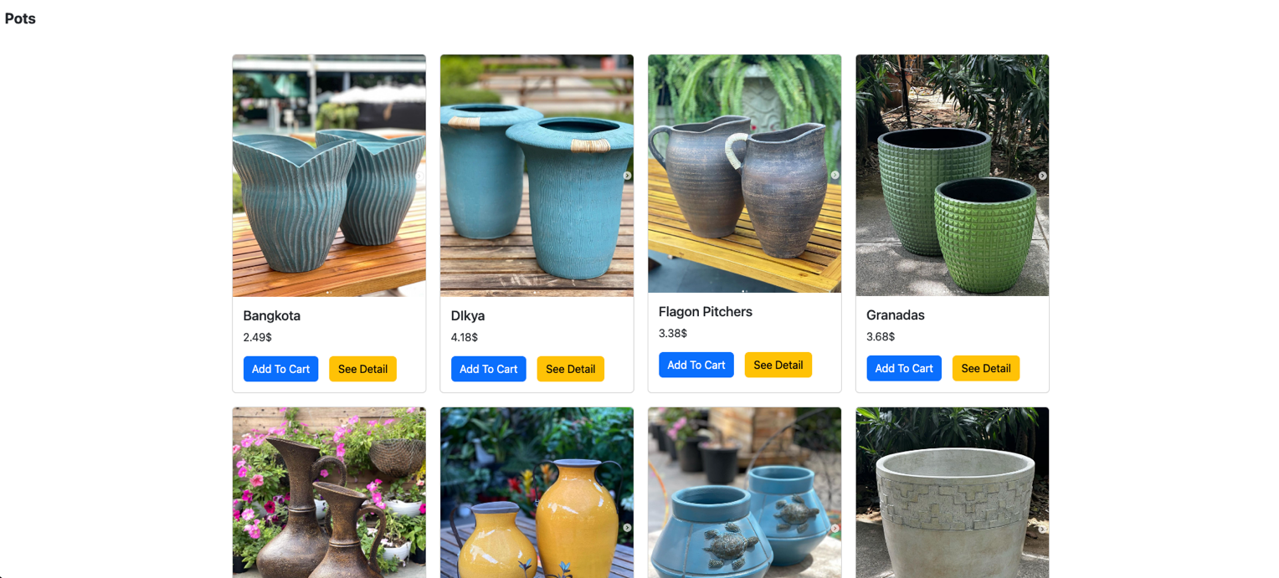

**Figure 1:** Product



**Figure 2:** Footer

## DETAIL PAGE

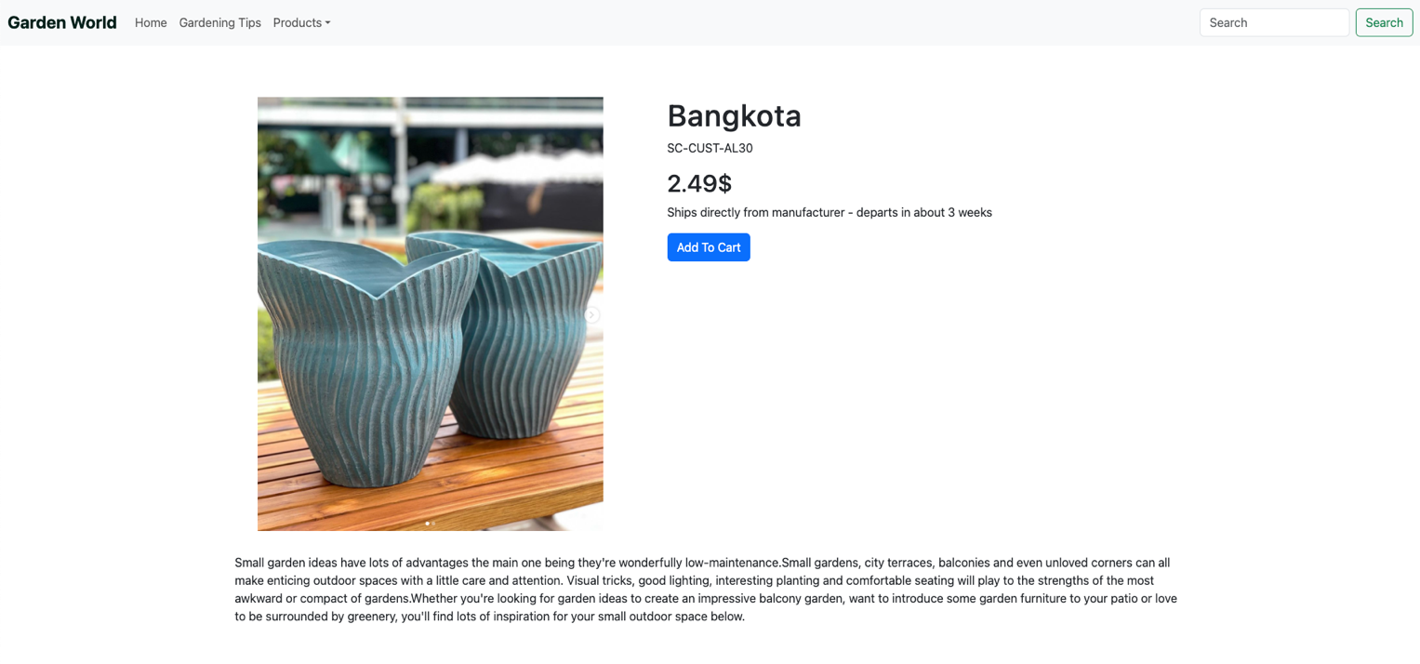

**Figure 1:** Detail Product



**Figure 2:** Footer

# SOURCE CODE

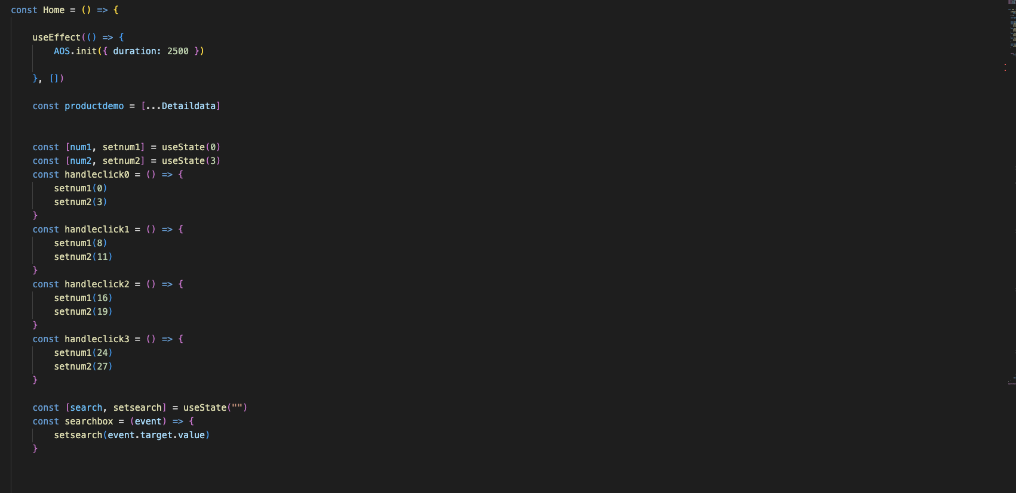

**Figure 1:** HomePage

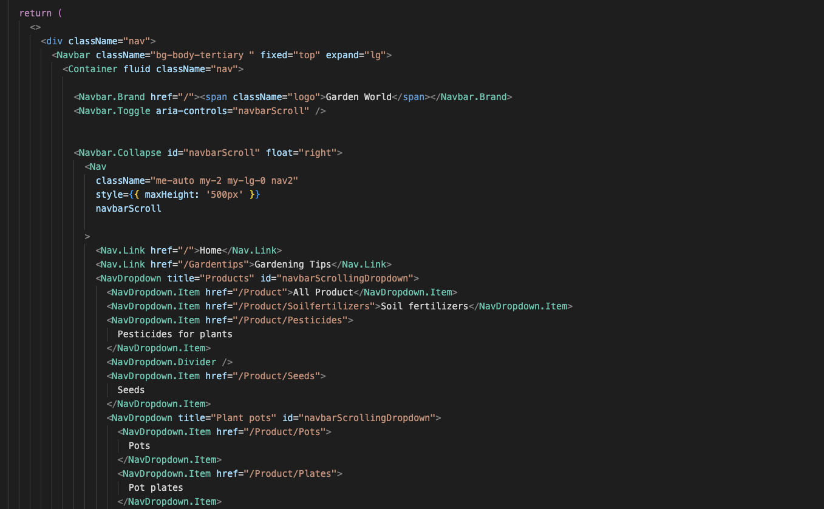

**Figure 2:** Gardening Tips

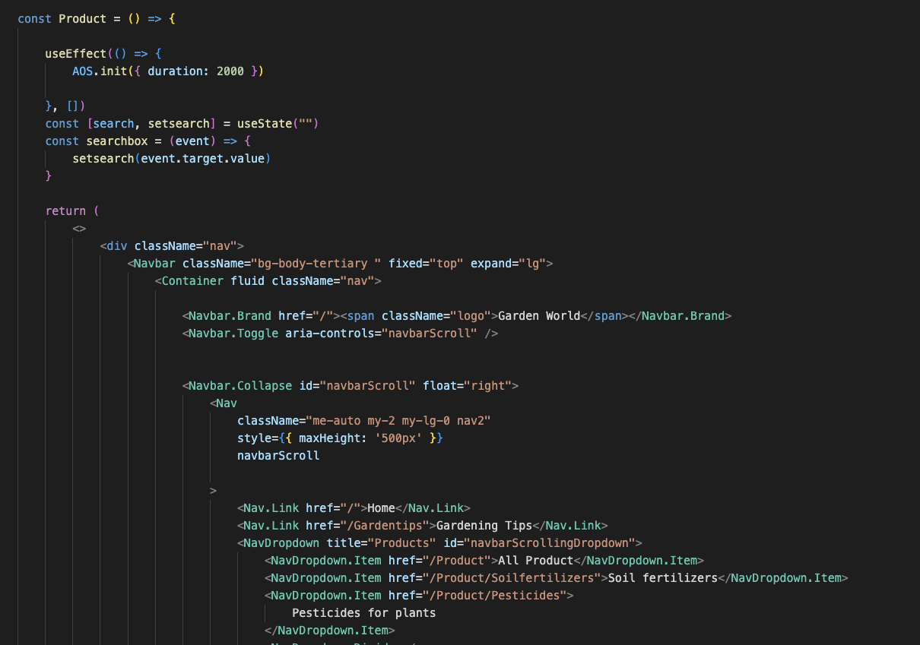

**Figure 3:** Product

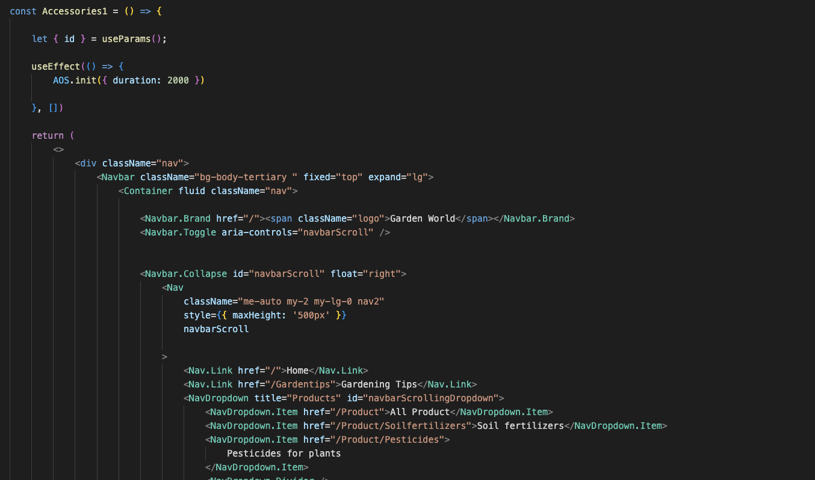

**Figure 4:** Detail

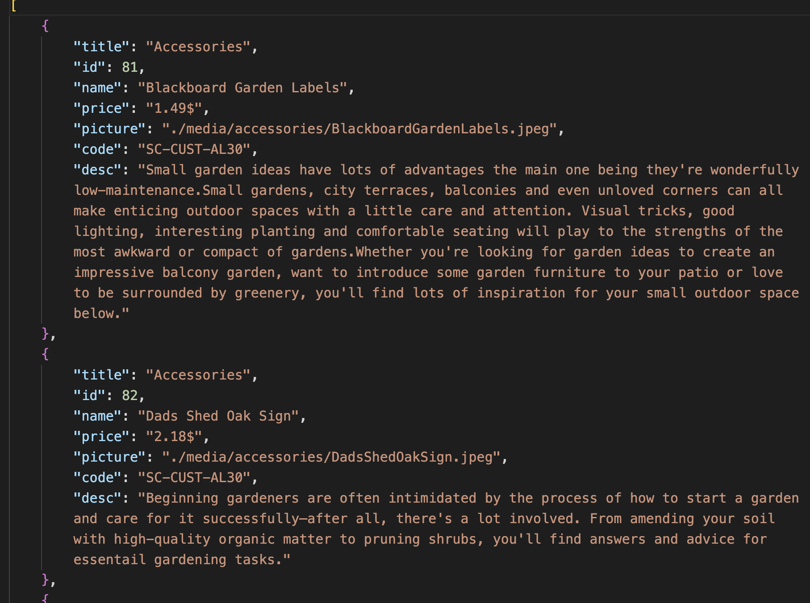

**Figure 5:** Data Json

# TASK SHEET REVIEW 3

|  |  |  |  |  |  |  |  |
| --- | --- | --- | --- | --- | --- | --- | --- |
| **Project Ref. No.:**  **eP/Advertisement**  **Portal Management System/01** | | **Project Title:** | **Activity Plan Prepared By:** | **Date of Preparation of Activity Plan:** | | | |
| **Sr.**  **No.** | **Task** | **Actual**  **Start Date** | **Actual Days** | **Team**  **Mate Names** | **Status** |
| 1 | Homepage | GardenWorld | Son | 30-Oct-2023 | 1 | Nguyen, Hieu,  Son | Completed |
| 2 | Gardening Tips | 30-Oct-2023 | 1 | Nguyen, Hieu,  Son | Completed |
| 3 | Product | 30-Oct-2023 | 1 | Nguyen, Hieu,  Son | Completed |
| 4 | Detail | 30-Oct-2023 | 1 | Nguyen, Hieu,  Son | Completed |

|  |  |
| --- | --- |
| **Date: 5/10/2023** | |
| Signature of Instructor:  **Mr. Nguyen Phat Tai** | Signature of Team Leader:    **Ms. Nguyen Minh Hieu** |